# CMPT 365 Project 2

## Audio Compression

The wavefile reader uses a Java Wav File IO class made by A.Greensted.

The Huffman encoding algorithm is made by Marvin Jason.

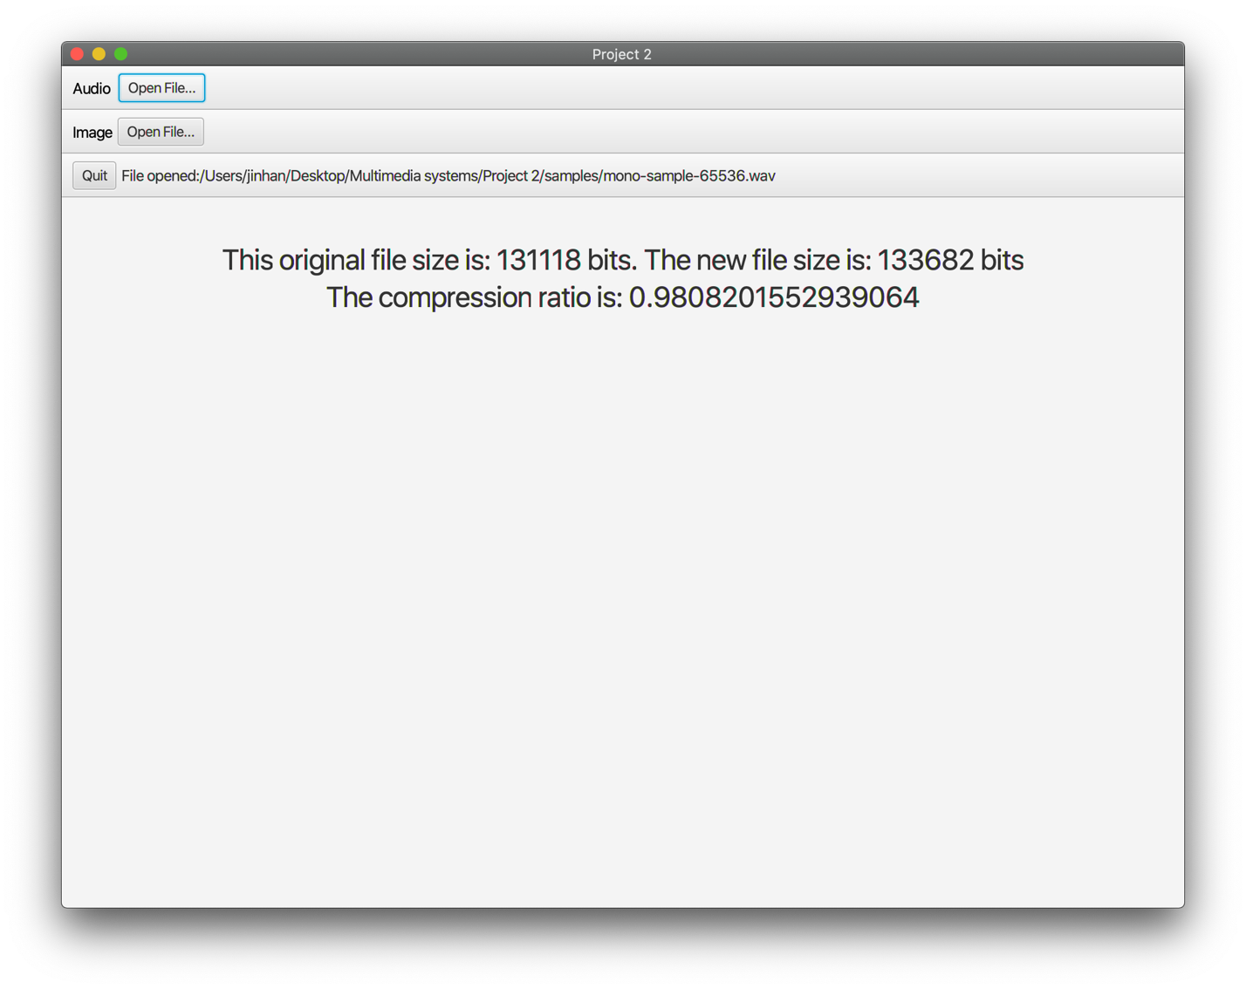

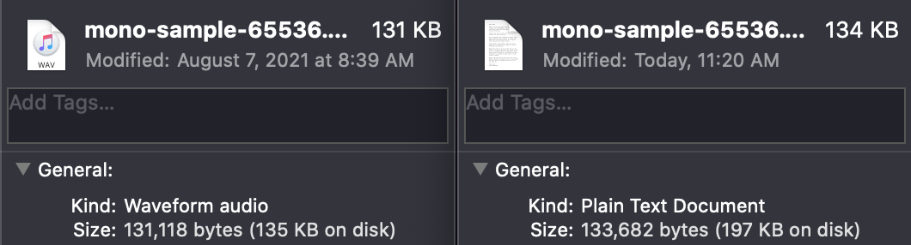

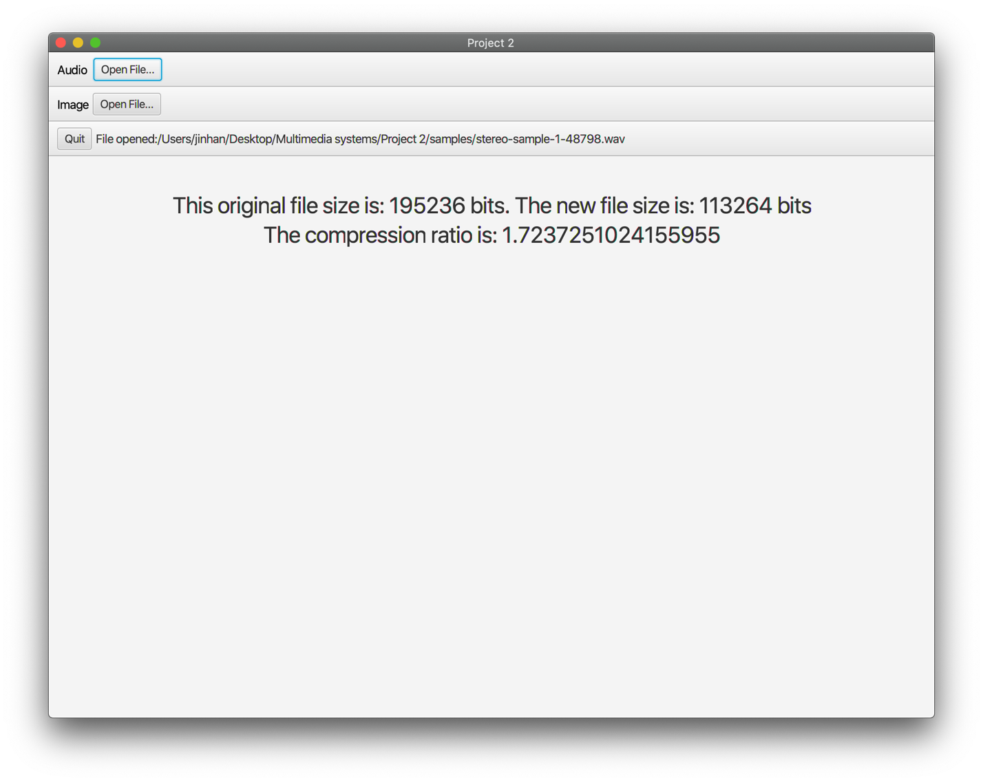

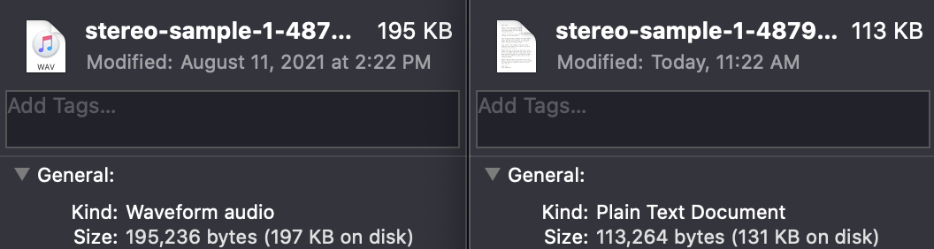

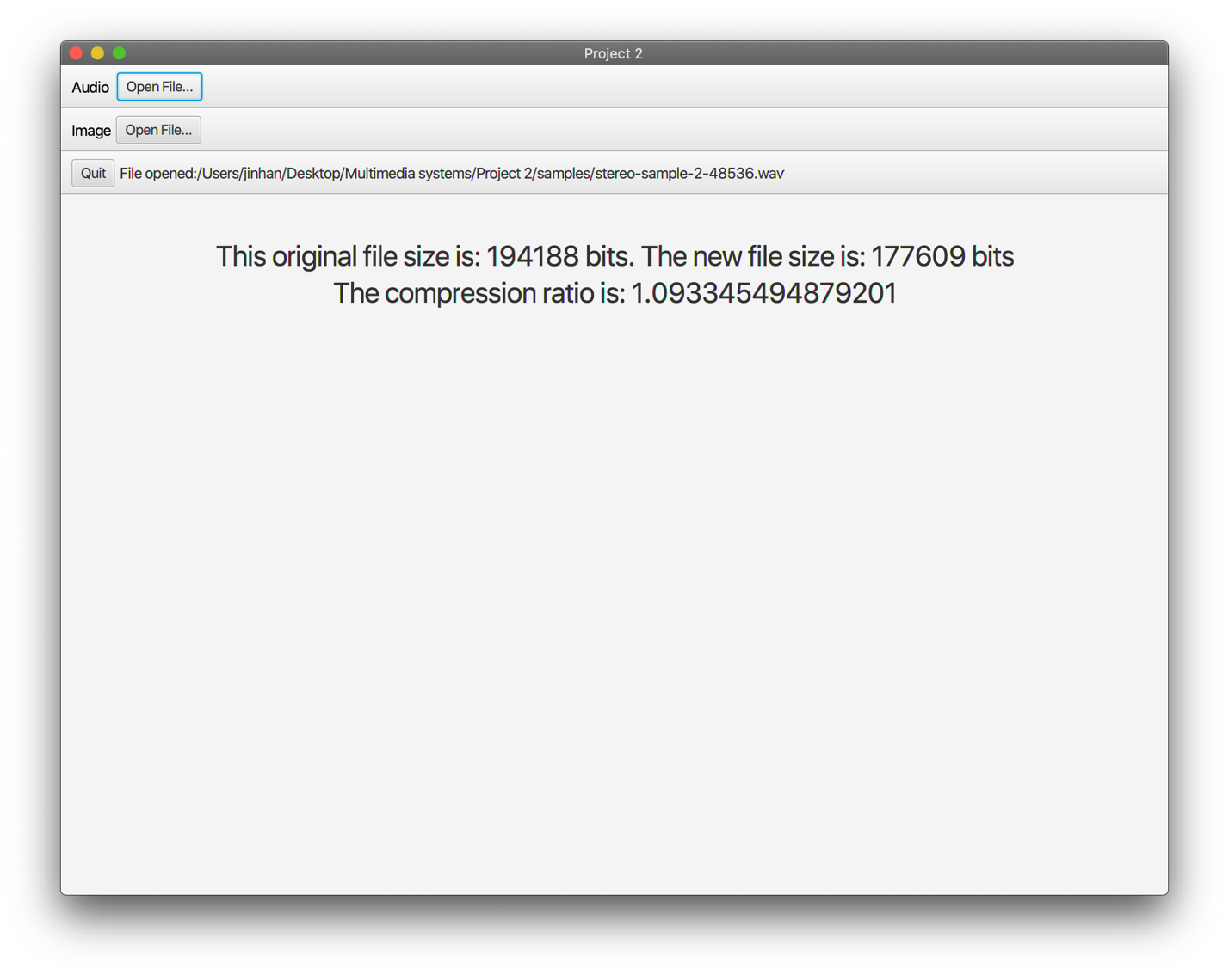

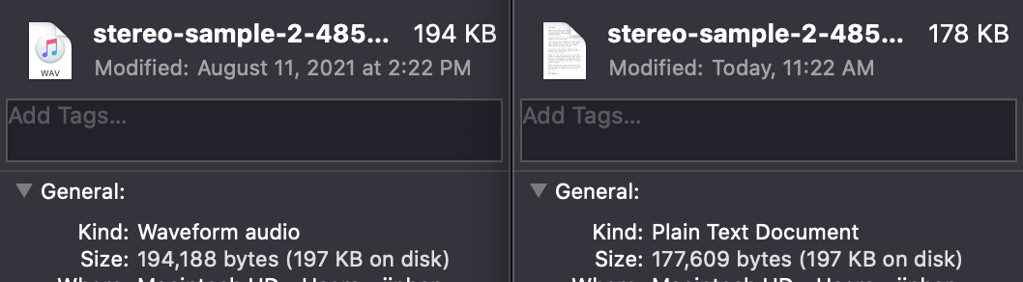

The compression algorithm first calculates channel coupling using the method found on monkeysaudio.com, which calculates the mid channel using (l+r)/2 and a side channel using (l-r). It will only do this to stereo files, the data from mono files are not modified.

Secondly, linear prediction is applied to both mono and stereo files on all available channels. The linear prediction algorithm calculates the difference between $x_{i}$ and $x_{i-1}$, and stores the result in $x_{i}$. The algorithm operates from $i=n$ to $i=0$, so the comparison will always be done on the original values.

Finally, an external Huffman library made by Marvin Jason is called to encode the numerical data into binary. The original string is a set of numbers separated by comma to indicate different channels and separated by semicolons to indicate different samples. The result is then converted into individual bytes and written into a .txt file. The TXT file also includes a dictionary for the Huffman encoding on top. The WAV header is not included in the output, but the effect on file size (44 bytes) is minimal.

As we can see, the compression rate fluctuates wildly from file to file, and it appears to do poorly on mono files. This can be due to the lack of channel coupling on mono files, which on stereo files, reduces the value stored in each channel for better compression.

The stereo files have the compression rate of 58% and 91%, which averages to 74.5%, making this algorithm worse than FLAC encoding. The difference is mostly due to the linear prediction algorithm used in this encoding scheme. The algorithm does not have a scaler value which adapts dynamically to the encoding quality. This can also explain the huge difference between files, as the lack of dynamic scaling will cause files with massive fluctuations to be poorly encoded, and files with minimal fluctuations to be better encoded.

Encoding the files take less than a second on a modern laptop. It is possible to decode the file into its original form, because the samples and channels are separated with a delimiter. It is, however, outside the scope of this project.

## Image Compression

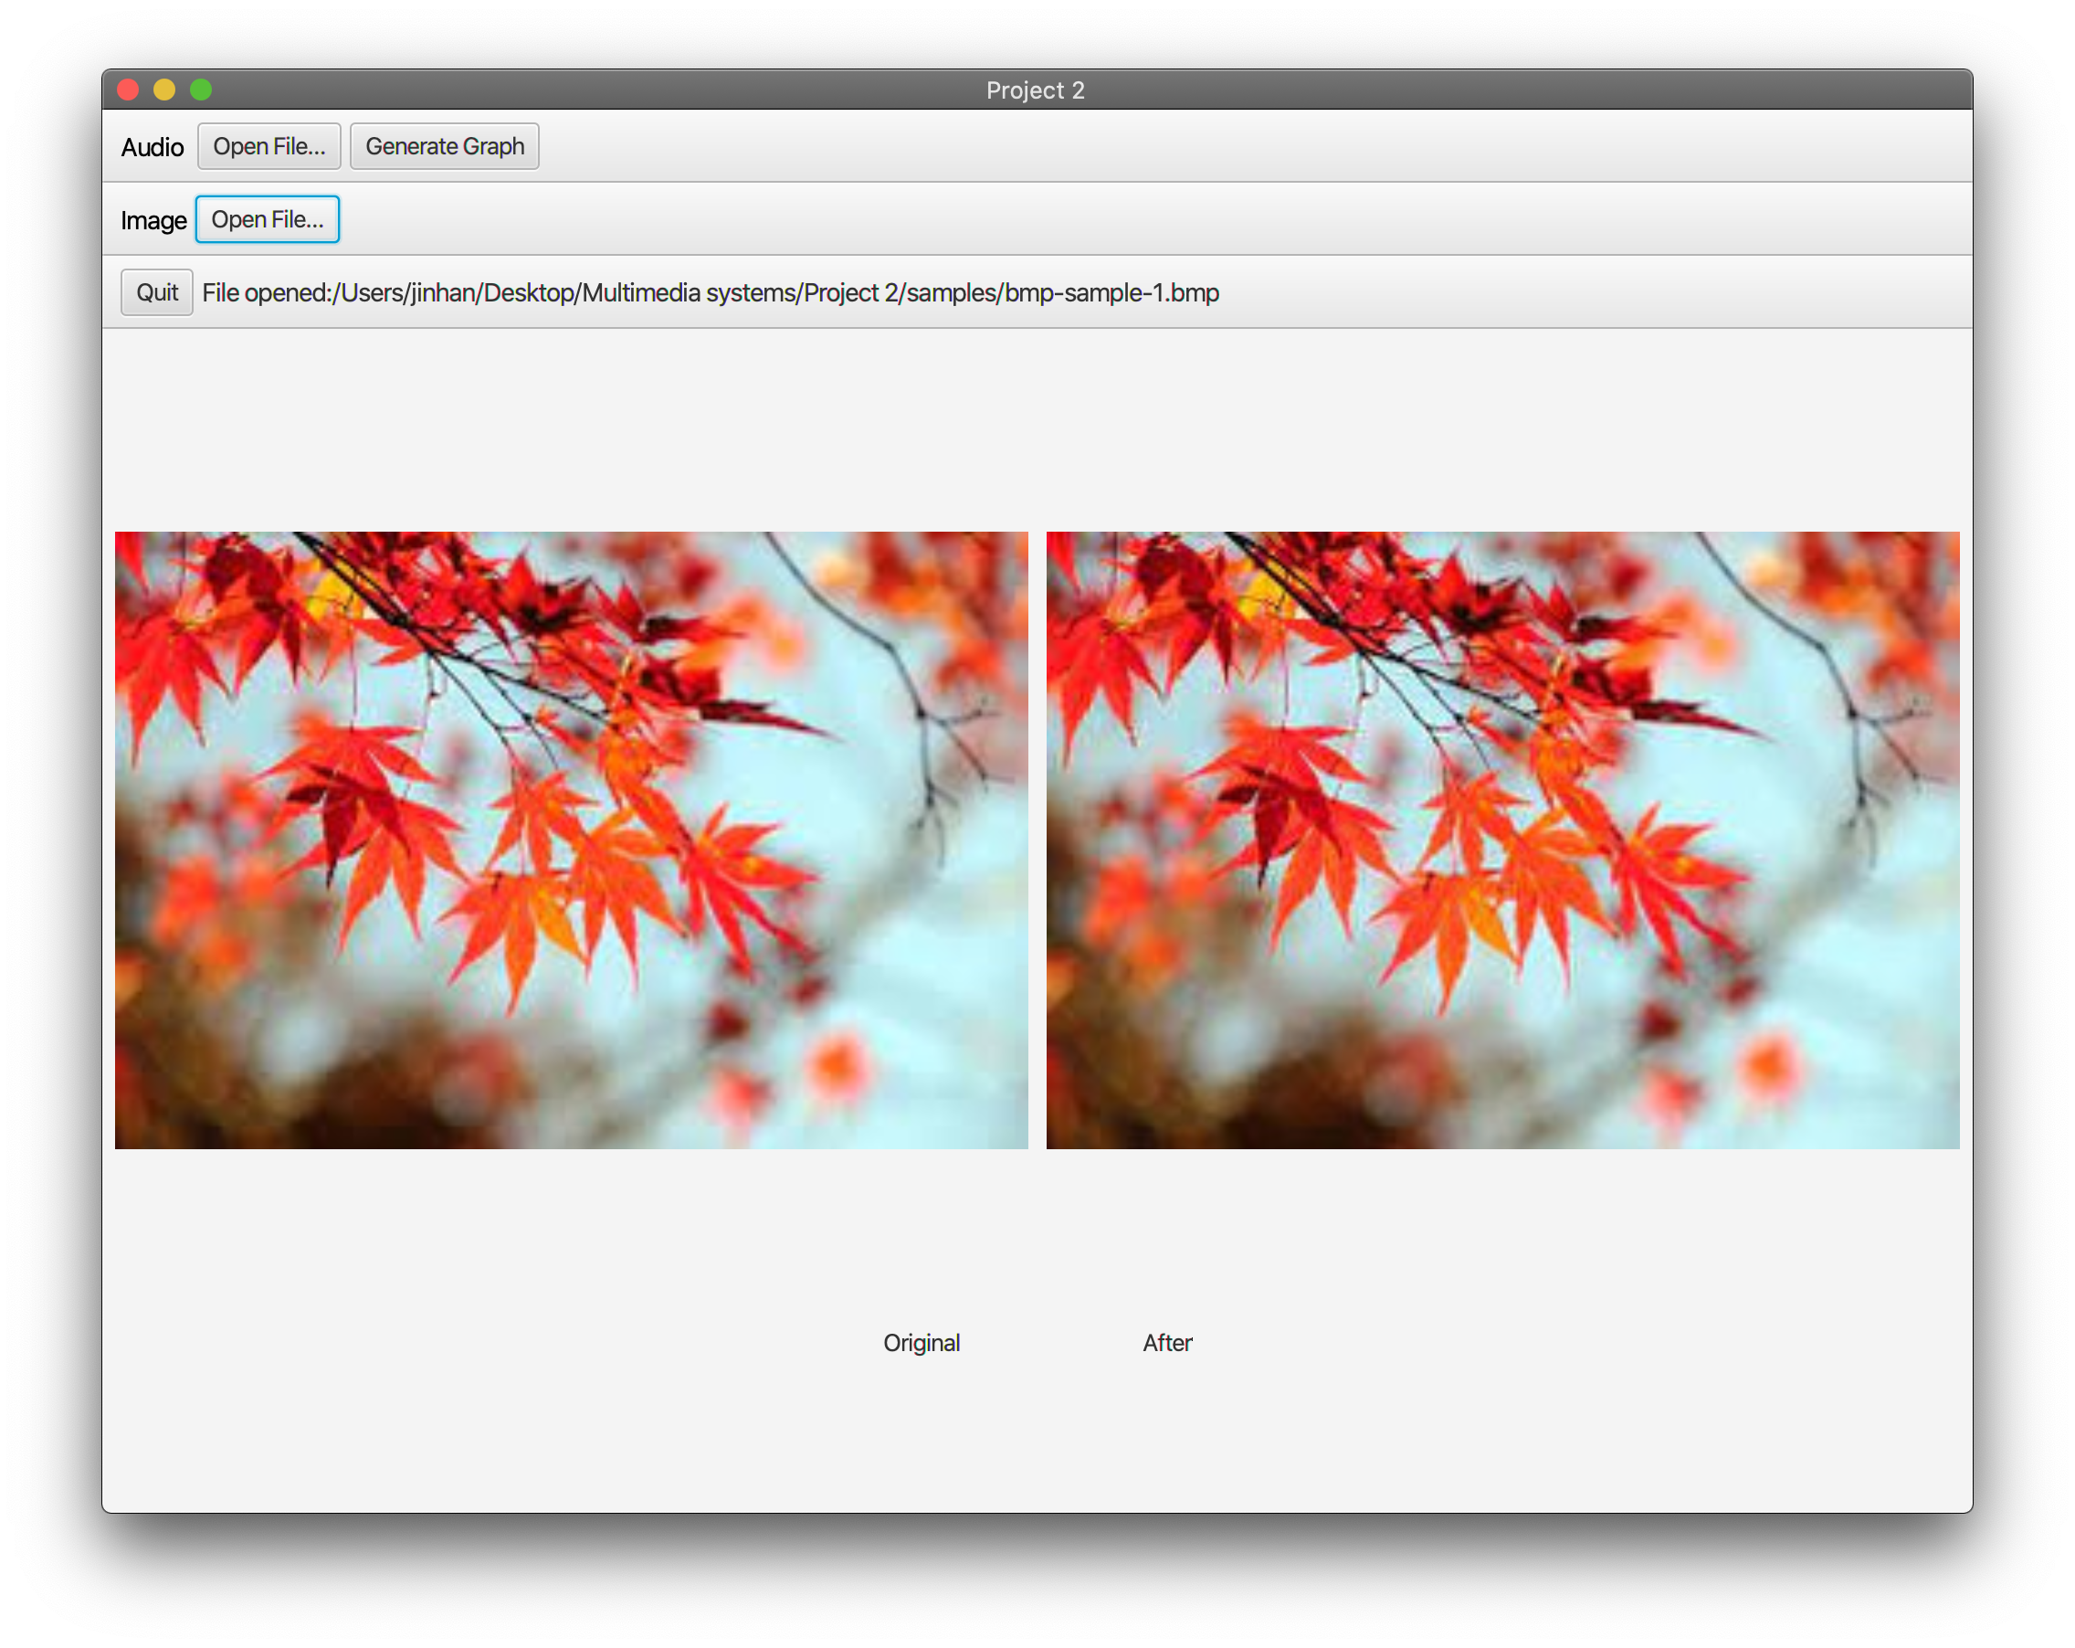

Before and After

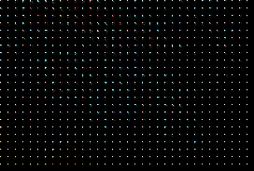

Quantized Result

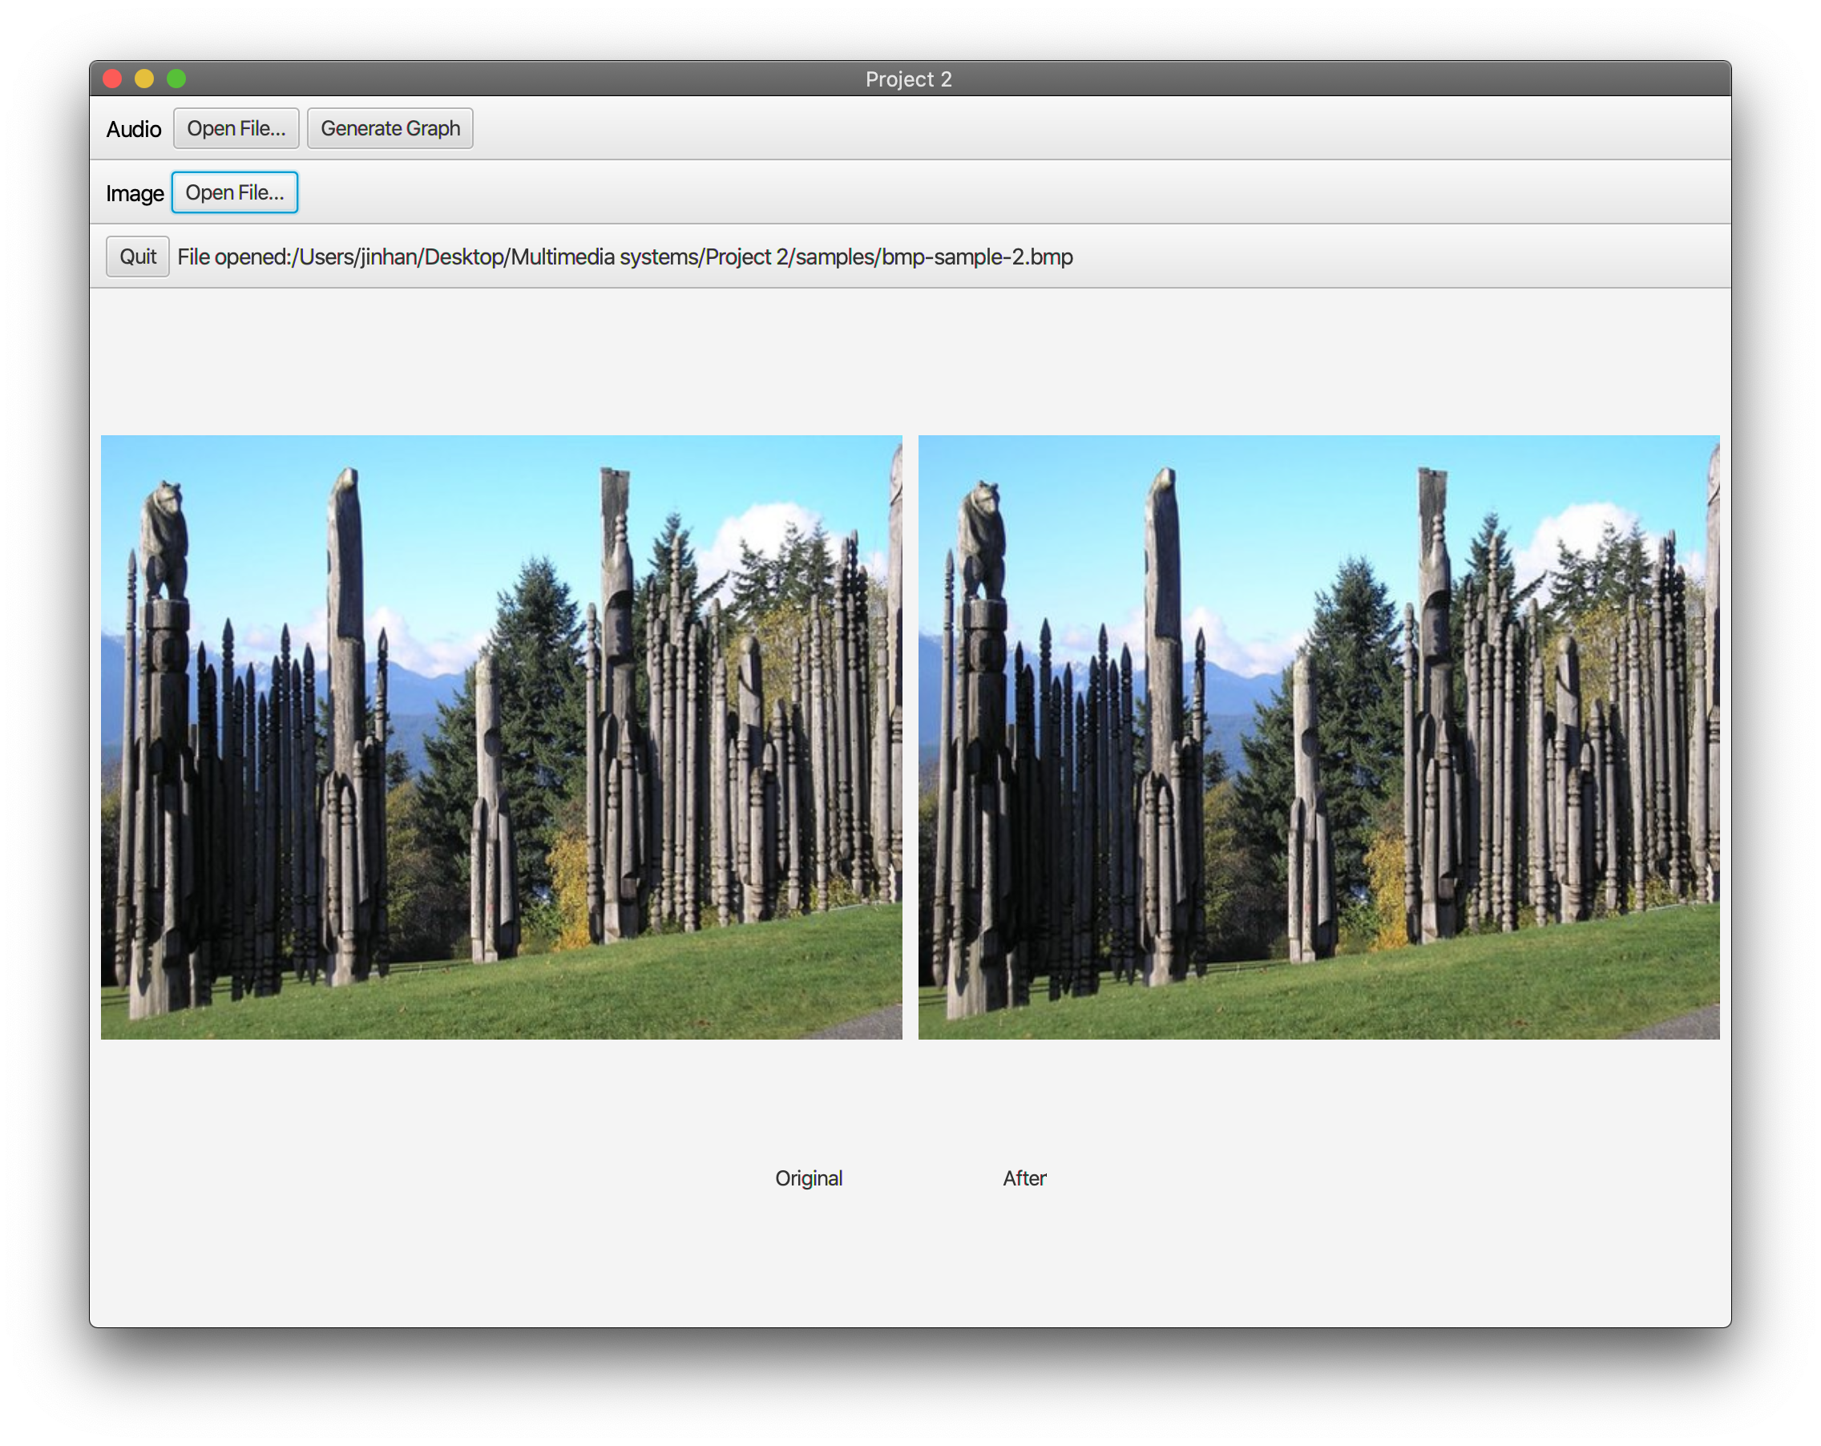

Before and After

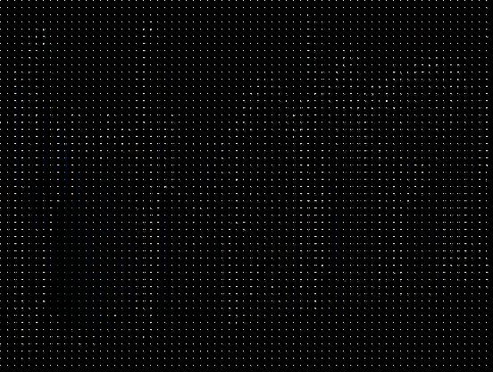

Quantized Result

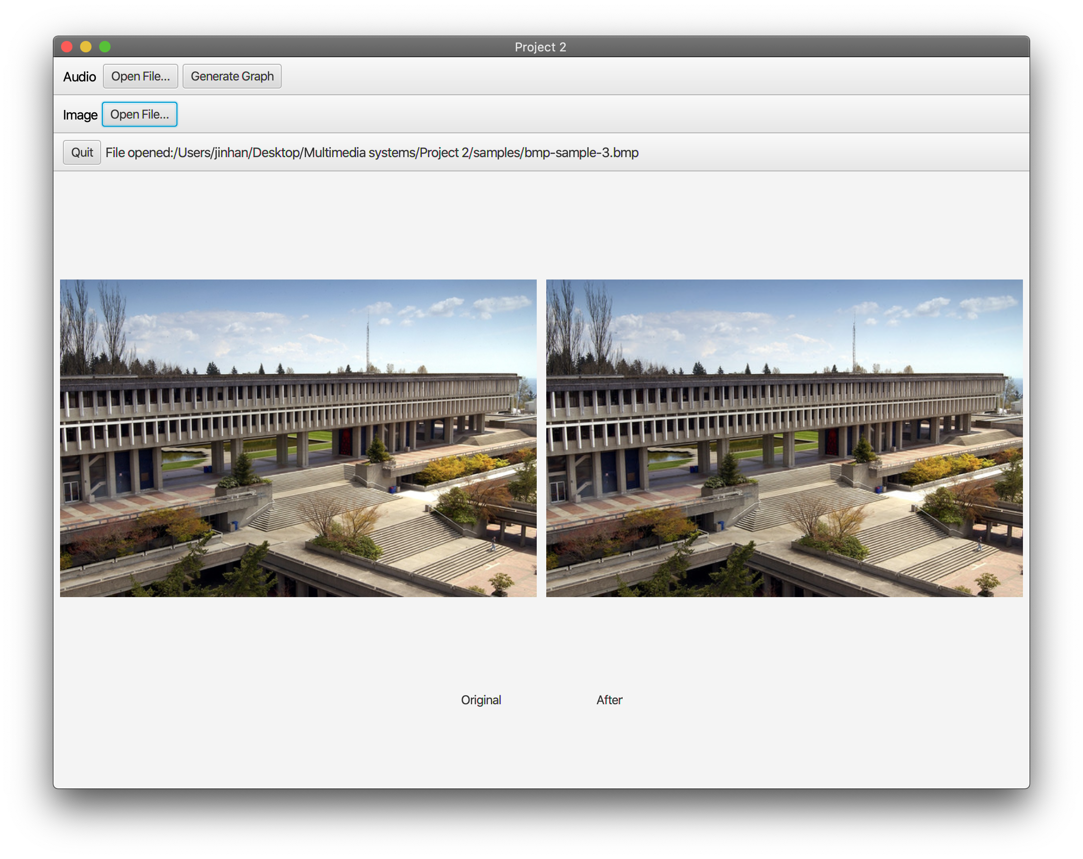

Before and After

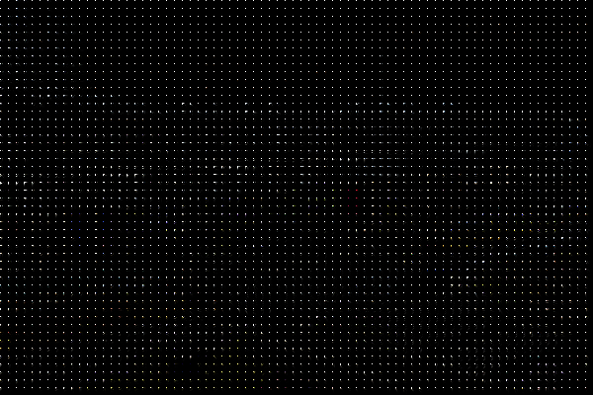

Quantized Result

The program runs on O(N) time as conversion is done on each pixel. It executes quickly with minimal delay on a modern laptop.

The quantized image has all energy concentrated to the upper left of each 8x8 grid. Thanks to dequantization, there is no significant changes to the decompressed file.

If dequantization is not applied, the resulting image can seem fuzzy and transitions between each 8x8 block will be jarring.

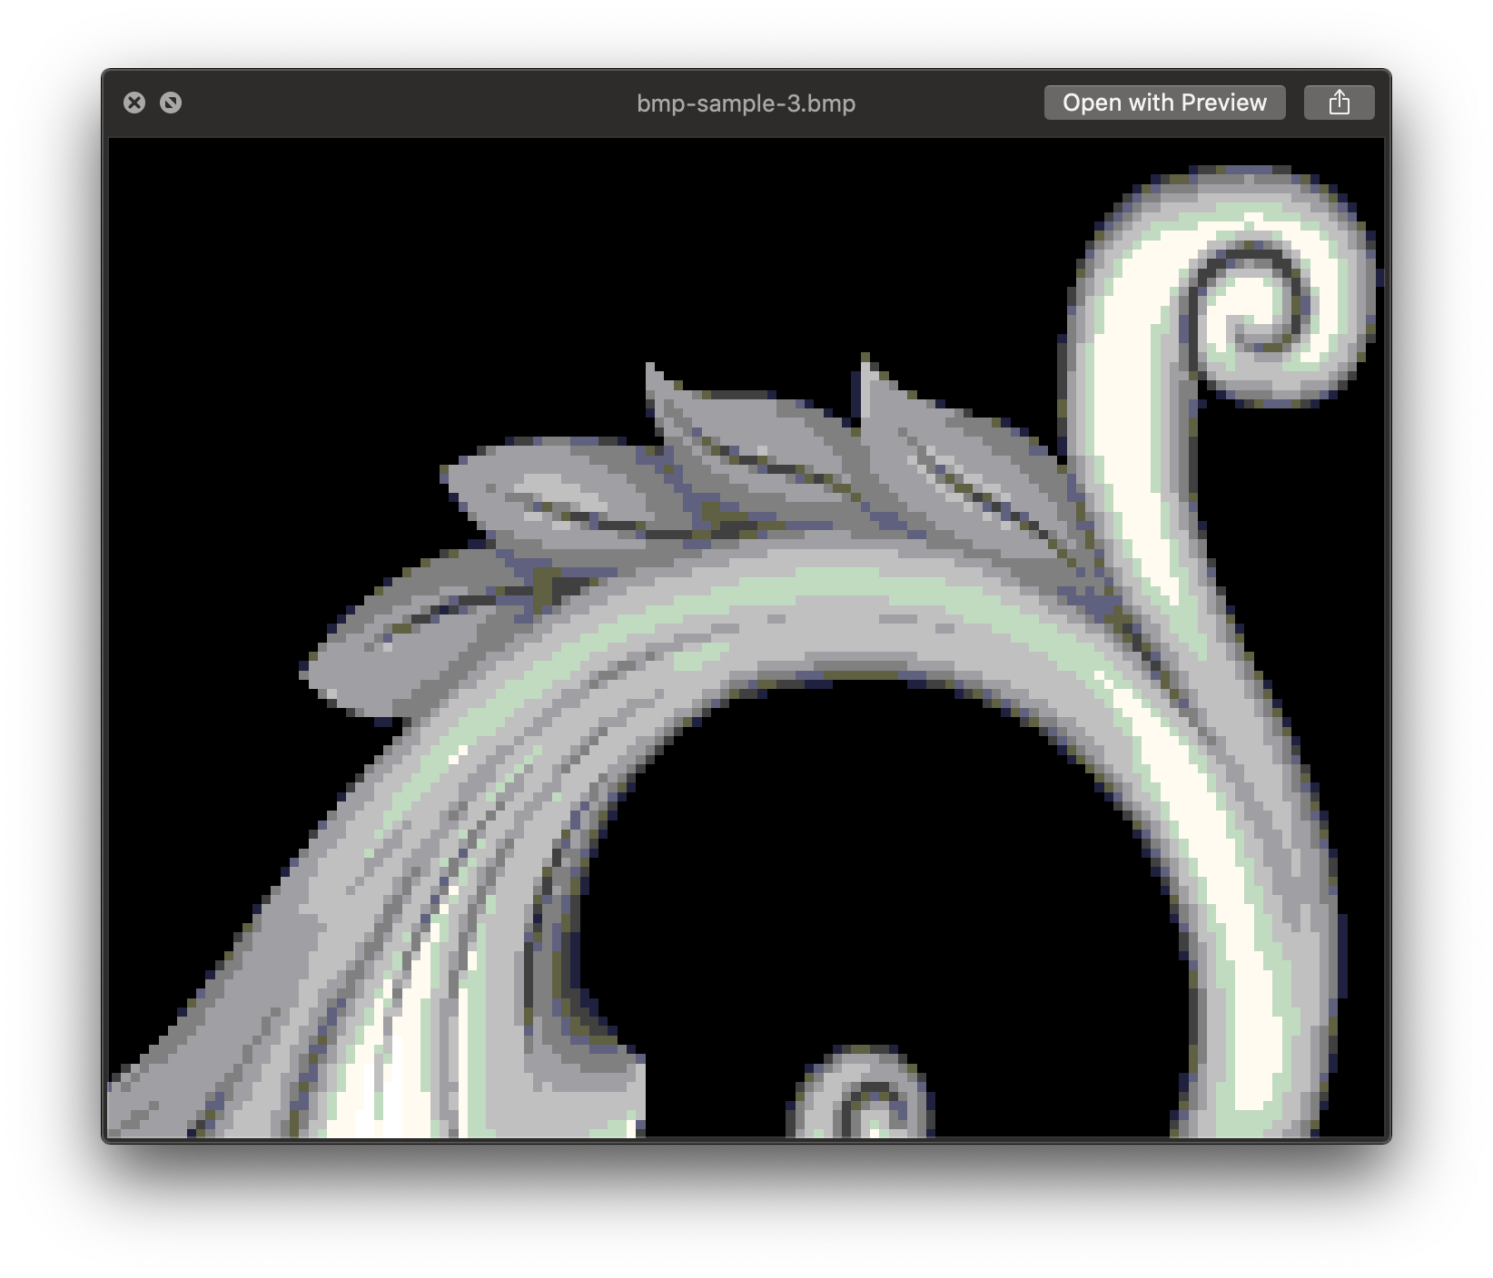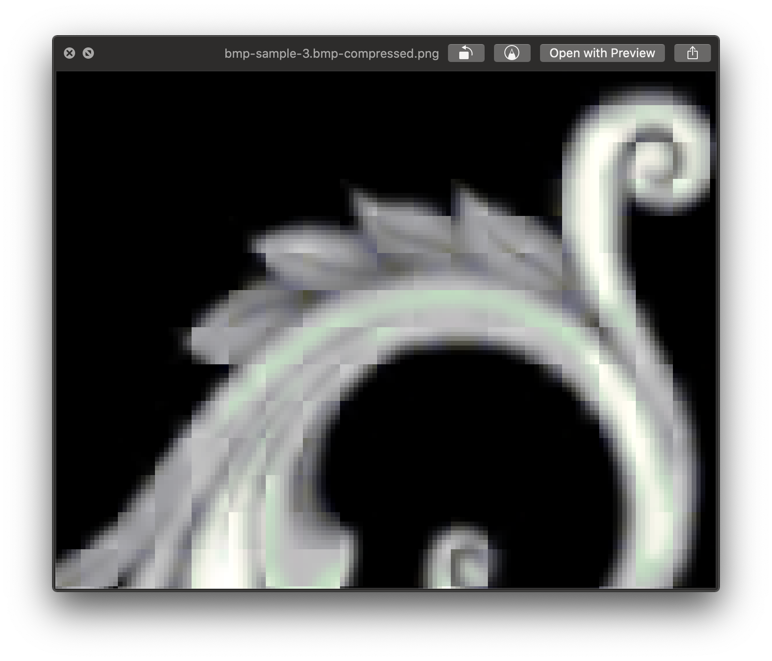

Before and After (no de-quantization)

With dequantization, there is smearing and block artifacts due to quantization loss, but the overall image retains most of the information to not appear visibly different unless zoomed in substantially.

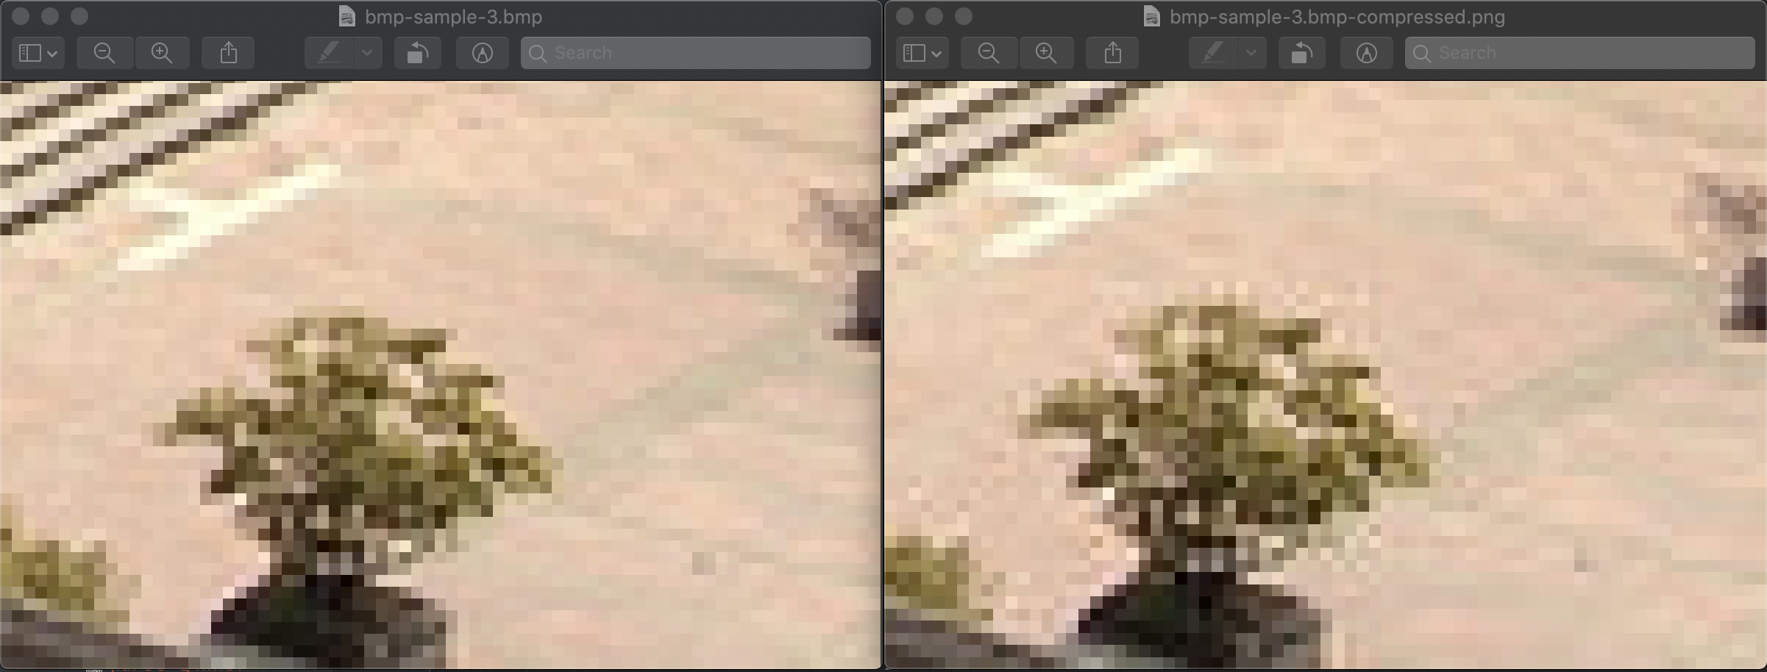

Before and After (with dequantization)

For Q2, all code have hard-coded matrix properties, meaning they will only apply to images with height and width that are multiples of 8. It would be possible to optimize the approach to introduce a general-use algorithm for images of any dimension. In terms of compression, it’s also possible to apply Huffman encoding to further suppress file size, but that is not part of the project requirement.

## Reference:

https://github.com/marvinjason/HuffmanCoding

http://www.labbookpages.co.uk/audio/javaWavFiles.html

http://soundfile.sapp.org/doc/WaveFormat/

https://monkeysaudio.com/theory.html

https://docs.oracle.com/javase/8/javafx/api/javafx/scene/image/PixelWriter.html

https://docs.oracle.com/javase/tutorial/java/nutsandbolts/datatypes.html

https://www.geeksforgeeks.org/stringbuilder-class-in-java-with-examples/

https://stackoverflow.com/questions/5263187/print-an-integer-in-binary-format-in-java#5263199

https://stackoverflow.com/questions/36782231/printing-a-java-map-mapstring-object-how

https://stackoverflow.com/questions/59246658/how-do-i-access-a-specific-index-in-a-string-in-java

https://zetcode.com/java/filesize/